Bolt-Hole Corner Crack Detection Using Computer Vision Techniques and Eddy Current Surface Images

Tracy Petrie
University of Colorado at Colorado Springs
Colorado Springs, CO 80919

Daron Anderson
University of Colorado at Colorado Springs
Colorado Springs, CO 80919

Abstract
Aircraft that are in use every day are getting older. A significant concern in airline industry is the safety hazards presented by deterioration of aircraft. A serious difficulty with aircraft inspections is the inability to detect defects in the regions where two pieces of metal overlap and hairline cracks that are undetectable by the human eye. In particular, cracking may occur at fastener points during the lifetime of an aircraft. This type of flaw is difficult to accurately detect and poses a large safety risk in air travel. There is currently a need in the field of aircraft inspection for automating a process that can reliably detect such flaws while an aircraft is on the tarmac.
Surface images of aircraft can be captured using various Eddy Current scanning techniques⁽¹⁾. In this paper we focus on applying basic Computer Vision techniques to automatically predict the existence of flaws in the scanned surface and how significant the flaw is.

Introduction
Eddy Current (EC) sampling is a technology that can detect subsurface defects and hairline cracks in a non-invasive manner. EC samples a metal object along its surface at several points that form an approximate 2-D grid (with the X and Y step-sizes not necessarily equal). Each sample is a measure of voltage that correlates to the conductivity of the metal at that point. Cracks (as well as differing thickness of two volumes of metal) create variations in the measured voltage responses within of the surface. These voltages can then be interpolated and visually displayed as a kind of topological map. The process of collecting a 2-D grid of data points has been automated, but to the best of our knowledge, the use of computer vision techniques for automating defect detection has thus far not been developed.

Image Creation
Once some Eddy Current measurement device has collected the data, a surface image must be created. We used Algorithm 1 to store a data set from a file into an i by j matrix V, and produce a k by l matrix of pixels P, that represents the surface image. The matrix P is normally constructed to be several times larger than V because V is a highly discretized map of samples from the surface. Making P larger, and then interpolating the values of P using V, helps to remove much of the jaggedness that would otherwise result in P. The interpolation is performed using a weighted sums average of the sampled points that correspond to the area represented by each pixel.

Algorithm 1

- Read all data points into a matrix V.
- Create an image P that contains at least as many pixels in each dimension as the dimensions of V. If the step-size of the two dimensions of V differ, scale the axis with higher resolution to have that factor of more points. This will ensure that each pixel in P represents the same area in both dimensions.
- Compute the weighted value for each pixel in P.
- Scale the raw data points in P to grayscale setting the lowest voltage value in V to black and the highest voltage value to white
- Apply the Gaussian transformation in Algorithm 2 to each value in P.
- Apply a threshold to the pixel values to convert P from a grayscale image to a binary image.

In step 3 of Algorithm 1, the image P is initialized using a weighted average of the raw data stored in V. To perform this we use a neighborhood N of data points, and a maximum distance radius R. N is a 2n+1 by 2n+1 sub-matrix of V. R the radius of a circle that defines a boundary of allowed data points in V. R is a measure of linear distance from the surface point represented by P_{ij} and the surface point represented by V_{kl}. All values used in the weighted average must be simultaneously within N and R.
The weighted average computed for each pixel P_{ij} is computed using Equation 1. The data point V_{xy} is the nearest sampled surface point to the surface point represented by P_{ij}. Likewise, the data points V_{x+k,y+l} are the data points in N.

$$P_{\text{ij}}=\frac{\sum_{k=(−n)}^{n}{\sum_{l=(−n)}^{n}{[V_{x+k,y+l}}}×(D−d_{\text{kl}})]}{[(2n)^{2}−1]×D}$$
Equation 1

The distance values, d_{kl} are the Euclidean distances of the point (x,y) in P to the point (k,l) in V. The values x_{res} and y_{res} are the distances of any two adjacent surface sample points in the X and Y directions. Similarly, the value p_{res} is the surface distance between any two adjacent pixels in P.

$$d_{\text{kl}}=\sqrt{x_{{\text{dist}}^{2}}+y_{{\text{dist}}^{2}}}$$
Equation 2
$$x_{\text{dist}}=(x×p_{\text{res}})−(k×x_{\text{res}})$$
Equation 3
$$y_{\text{dist}}=(y×p_{\text{res}})−(l×y_{\text{res}})$$
Equation 4
and the sum of distances D is given by:

$D=\sum_{k=(−n)}^{n}{\sum_{j=(−n)}^{n}{d_{\text{kl}}}}$
Equation 5
The Gaussian transformation performed in step 5 of Algorithm 1 takes the scaled values computed in step 4 and computes their response to the Gaussian Distribution. Algorithm 2 performs this Gaussian transformation.

Algorithm 2

- Scale the response values of a Gaussian Distribution to a grayscale range setting 0 to black and the maximum value of the distribution to white.
- For each pixel in the image, compute the response of the Gaussian Distribution. Set the value of each pixel to the grayscale equivalent value determined in step 1.

This transformation highlights the values in the mid-gray range while suppressing values closer to the black and white. The goal with this transformation is to accentuate the differences between areas in the image that are changing rapidly from areas where the adjacent values are relatively constant. In other terms, we are attempting to eliminate all values from the image except where a large gradient exists. This will tend to eliminate much of the noise in the image.
Applying the Guassian transformation with μ = 255/3 (one third of maximum grayscale value) and σ = 20 to the image in Figure 1, we produced the image in Figure 2. It is clear that the Guassian transformation has suppressed everything in the image, except the boundaries between high and low voltage measurements.

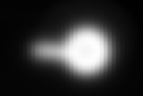
Figure 1 – n=3, radius=1.5

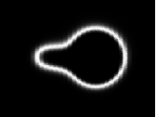
Figure 2 – μ=85, σ=20

Flaw Detection
Work on automating flaw detection occurred in parallel with the imaging effort. Initially, based on some very early work, the expectation was that images would be produced similar to the mocked up image in Figure 3.

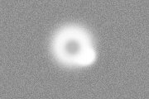
Figure 3 – Sample image
This image was pre-processed by applying a morphological closure (dilate then erode) to reduce the noise and the impact of the middle area of the rivet. Applying a standard 3x3 structure 14 times generated the image in Figure 4.

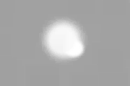
Figure 4 - Closed

The resultant image was then binary-thresholded with different values experimentally. Thresholded at 200 yielded a result seen in Figure 5.


Figure 5 - Thresholded
The next step in the process was to use the OpenCV library’s cvFindContours function searching for simple, external contours using the CV_RETR_EXTERNAL and CV_CHAIN_APPROX_SIMPLE arguments. The resulting contour can be seen mapped against the original image in the figure below:

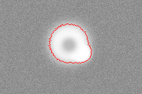
Figure 6 - Contoured
Using this contour, we were able to identify an “ideal circle” by radius and origin using a simple technique. By walking through the list of points contained in the contour and extracting minimum and maximum values in the X and Y direction, a bounding box was created. The “ideal circle” was then defined to be placed at the center of this bounding box with a radius equal to the average of the width and height of the box. Drawn in blue, this ideal circle, for this image, was placed as seen below:

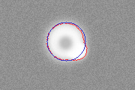
Figure 7 - Circled
Once the ideal circle was identified, three different techniques were used to attempt to identify the defect seen protruding to the lower right in the image.
The first technique was to simply examine all the points in the contour, calculate their distance from the origin, and compare that with the radius. Those points who’s difference was greater than some predetermined percentage would be flagged as defect regions. Below are the results filtered at different radius percentages:

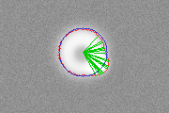
Figure 8 – 10% radius deviation
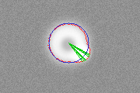
Figure 9 – 15% radius deviation
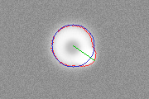
Figure 10 – 20% radius deviation
Easily visible is the fact that too low of a threshold introduces non-defect regions. Automatically determining some correct value is an area of further research.
The second method for defect detection was to calculate the standard deviation of the contour from the ideal circle. This calculation was made two different ways: calculating the standard deviation of the points in the contour from the origin, and calculating the standard deviation of the difference between the point-distance from the origin and the radius. Calculating the standard deviation from the origin appears to produce better results. Using the sample image again and applying the same threshold and closure values, the standard deviation images are:

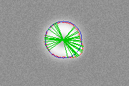
Figure 11 –Circumference SD = 1
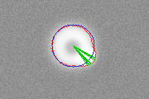
Figure 12 – Circumference SD = 2
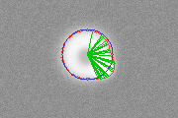
Figure 13 – Origin SD = 1
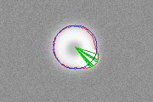
Figure 14 – Origin SD = 2

Such results were initially quite encouraging. Unfortunately, as actual images created from collected measurements came in, an obvious flaw in the algorithm was uncovered.
In this test image in Figure 15, the previously successful parameter values were applied as seen in Figure 16. Obviously, something has gone wrong.

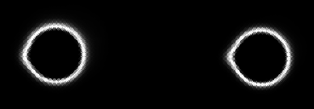
Figure 15 – First test image
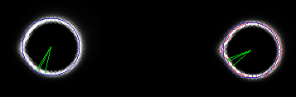
Figure 16 – First test using initial defect detection algorithm

Various experiments using different radius deviation parameters and different standard deviation parameters did not result in better success. Closer analysis suggested that the problem was the location of the ideal circle.
Examining the algorithm confirmed this. In the original synthesized images, the defect was off at an angle to the lower right and thus was not impacting the calculation of the bounding rectangle. The newly created test images had defects nicely aligned along the horizontal. This created a maximal skewing effect on the placement of the ideal circle which in turn threw off all deviation calculations.
Now the problem was to correct the location of the ideal circle. At some point we considered both Hough Transforms and Fast Circle Detection algorithms⁽²⁾, but these were rejected as too complex given the good results we were finding with the contour creation.
We opted to explore two different methods. The first method was rotationally-independent with respect to the defect. The second was more brute-force but compensated for horizontal or vertical defects. In method one, we calculated the X and Y offsets of each contour point relative to the ideal circle. To do this, we had to project the point onto the ideal circle using simple trigonometry illustrated in Figure 17.
Figure 17
From this diagram, one can see the ideal circle (the smooth thin arc), the contour (the thicker outer curve), and the point we’re interested in (x,y). Differentiating the origin from the point by using the notation O for origin and C for contour, we know the distance from the origin to the point is:
$$d=\sqrt{(O_{x}−C_{x})^{2}+(O_{y}−C_{y})^{2}}$$

This leads to:

$$\begin{aligned}Δx=({C_{x}}/d)(d−\text{radius}) \\ Δy=({C_{y}}/d)(d−\text{radius})\end{aligned}$$

The problem then becomes: how do we average these values in a way that weights the close deltas more heavily? Various schemes suggest themselves, but no rigorous solution was found in the timeframe required. Ad-hoc attempts at ‘intuitive’ formulas did not yield success either.
We then moved to the brute-force method. Here, we took the minimum dimension of the bounding rectangle (using our earlier method to calculating it) as our radius (as opposed to the average of the two dimensions). We then ‘slid’ the ideal circle along the larger dimension one pixel at a time calculating the standard deviation of the resultant placement (again using our earlier methods). We then chose the placement of the circle that generated the minimum standard deviation. Figure 18 shows the placement of the circle using the old method, Figure 19 shows it using the new method.

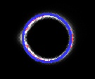
Figure 18 – Old Circle Placement
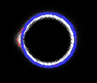
Figure 19 – New Circle Placement
Using this new method of defining the ideal circle, we observed the following results:

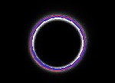
Figure 20 – No defect image (none detected)

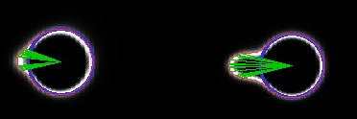
Figure 21 – Circumference, 1 SD, large defect

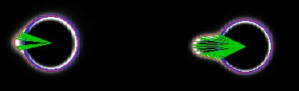
Figure 22 – Radius, 15%, large defect

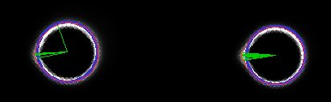
Figure 23 – Origin, 1SD, small defect

A more comprehensive display of results by deviation parameter and method can be seen at:

http://www.marcad.com/CS584/Proj2

Future Work
Although we have achieved some initial success, there are still several things that we wish to pursue in order to create a robust, accurate corner crack detection system:
- Improve the weighted sums averaging algorithm. This algorithm currently works for most neighborhoods of interest, but breaks down when the neighbor hood is 0 or 1.
- Add algorithm to pre-compute the ‘best’ values for the μ and σ of the Gaussian Distribution in Algorithm 2. This will make the detection algorithm more robust, because it will be able to accept any surface image, without requiring a priori knowledge about the content of the image.
- Improve the algorithm that detects circles in the image.
- Test the effects of modifying the parameters to algorithms 1 and 2, and determine an accurate error detection mechanism to classify and quantify these errors.
- Identify an averaging algorithm for contour deviations from an initially placed ideal circle to enable rotationally-independent defect detection.

References
- Tai, Cheng-Chi, and John C. Moulder., “Bolt-Hole Corner Crack Inspection Using the Photoindiuctive Imaging Method,” in Journal of Nondestructive Evaluation, Vol 19, No. 3, (Plemium, New York, 2000), p. 81.
- Rad, Faez, and Qaragozlou, “Fast Circle Detection Using Gradient Pair Vectors,” in Proc. VIIth Digital Image Computing: Techniques and Applications, (Syney, 2003), p. 879-887.

